Scenario: 1
Completions:
API: https://api.groq.com/openai/v1/chat/completions
{"role": "system", "content": "You are a helpful assistant."},
{"role": "user", "content": "Explain the postman methods in API"
Input JSON:
{
"model": "llama-3.3-70b-versatile",
"messages": [
{"role": "system", "content": "You are a helpful assistant."},
{"role": "user", "content": "Explain the postman methods in API"}
],
"temperature": 0.7,
"max_completion_tokens": 1024
}

Output JSON
id: chatcmpl-1ea641f5-86f9-4ddb-af1d-09b9c242801c object: chat.completion created: 1781872155 model: llama-3.3-70b-versatile choices: index: 0 message: role: assistant content: **Postman Methods in API** ========================== Postman is a popular tool used for building, testing, and documenting APIs. It supports various HTTP request methods, which are used to interact with APIs. Here are the main Postman methods in API: ### 1. **GET** * **Purpose:** Retrieve data from a server. * **Description:** The GET method is used to fetch data from a server. It is the most commonly used method in APIs. * **Example:** `GET https://api.example.com/users` ### 2. **POST** * **Purpose:** Create new data on a server. * **Description:** The POST method is used to send data to a server to create a new resource. * **Example:** `POST https://api.example.com/users` ### 3. **PUT** * **Purpose:** Update existing data on a server. * **Description:** The PUT method is used to update an existing resource on a server. * **Example:** `PUT https://api.example.com/users/1` ### 4. **DELETE** * **Purpose:** Delete data from a server. * **Description:** The DELETE method is used to delete a resource from a server. * **Example:** `DELETE https://api.example.com/users/1` ### 5. **PATCH** * **Purpose:** Partially update existing data on a server. * **Description:** The PATCH method is used to partially update an existing resource on a server. * **Example:** `PATCH https://api.example.com/users/1` ### 6. **HEAD** * **Purpose:** Retrieve metadata about a resource. * **Description:** The HEAD method is used to retrieve metadata about a resource, such as its headers. * **Example:** `HEAD https://api.example.com/users` ### 7. **OPTIONS** * **Purpose:** Describe the supported HTTP methods for a resource. * **Description:** The OPTIONS method is used to describe the supported HTTP methods for a resource. * **Example:** `OPTIONS https://api.example.com/users` ### 8. **CONNECT** * **Purpose:** Establish a tunnel to a server. * **Description:** The CONNECT method is used to establish a tunnel to a server, which can be used for proxying HTTPS requests. * **Example:** `CONNECT https://api.example.com` ### 9. **TRACE** * **Purpose:** Perform a loop-back test. * **Description:** The TRACE method is used to perform a loop-back test, which can be used for debugging purposes. * **Example:** `TRACE https://api.example.com` In summary, these Postman methods are used to interact with APIs and perform various actions such as retrieving, creating, updating, and deleting data. **When to Use Each Method** --------------------------- * Use **GET** to retrieve data. * Use **POST** to create new data. * Use **PUT** to update existing data. * Use **DELETE** to delete data. * Use **PATCH** to partially update existing data. * Use **HEAD** to retrieve metadata. * Use **OPTIONS** to describe supported HTTP methods. * Use **CONNECT** to establish a tunnel. * Use **TRACE** for debugging purposes. By understanding the different Postman methods, you can effectively interact with APIs and perform various actions. logprobs: finish_reason: stop usage: queue_time: 0.363002318 prompt_tokens: 49 prompt_time: 0.002190832 completion_tokens: 672 completion_time: 1.511216774 total_tokens: 721 total_time: 1.513407606 usage_breakdown: system_fingerprint: fp_0761e44d7b x_groq: id: req_01kvfxpmwjex2vvec9g4shwe8z seed: 2008968977 service_tier: on_demand
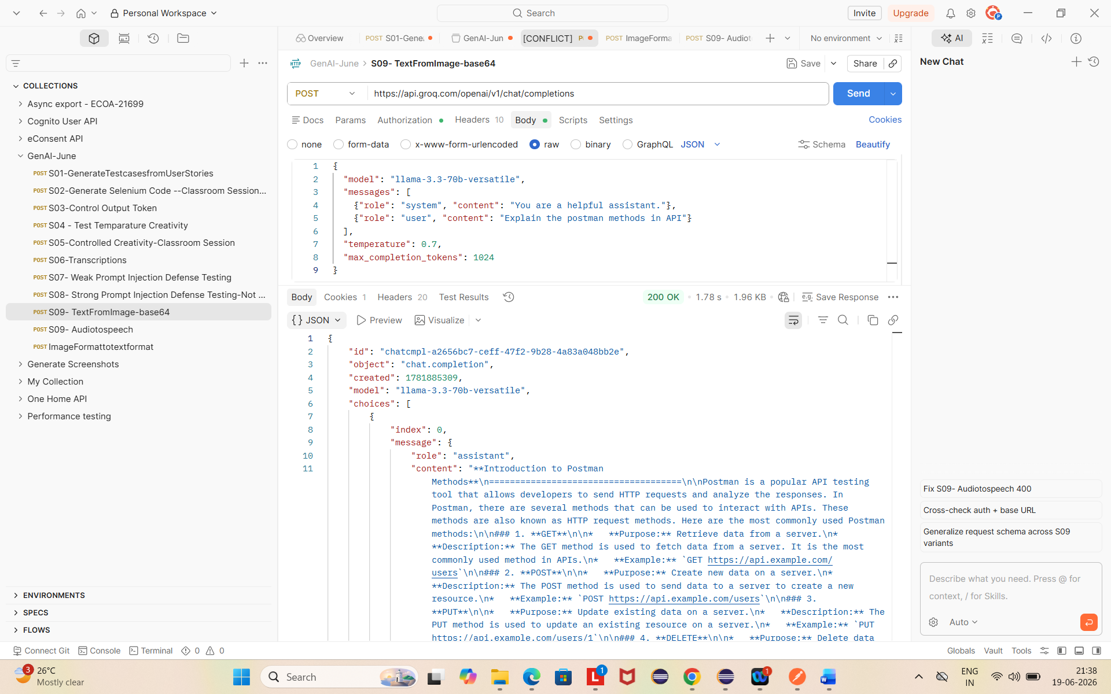

Scenario: 2
Image to Text:
Input Json:
{
"model": "meta-llama/llama-4-scout-17b-16e-instruct",
"messages": [
{
"role": "user",
"content": [
{
"type": "image_url",
"image_url": {
"url": "https://plain-apac-prod-public.komododecks.com/202606/19/nRaD9sy7ix6OvvekPvGL/image.png"
}
},
{
"type": "text",
"text": "Describe what you see in this image in detail."
}
]
}
],
"max_completion_tokens": 1024
}
Output Json
{
"id": "chatcmpl-7077b417-894a-4234-8704-0e8f1d122445",
"object": "chat.completion",
"created": 1781885177,
"model": "meta-llama/llama-4-scout-17b-16e-instruct",
"choices": [
{
"index": 0,
"message": {
"role": "assistant",
"content": "The image presents a stylized representation of the Amazon logo. The logo features the word \"amazon\" prominently. A curved line resembling a smile is positioned underneath the text, with an arrowhead at its end, pointing towards the right side of the image. The entire logo is rendered in white. The background of the image is solid black, providing a striking contrast to the logo's design. The overall effect is one of simplicity and elegance, effectively conveying the brand's identity."
},
"logprobs": null,
"finish_reason": "stop"
}
],
"usage": {
"queue_time": 1.100924572,
"prompt_tokens": 169,
"prompt_time": 0.007211578,
"completion_tokens": 97,
"completion_time": 0.219267288,
"total_tokens": 266,
"total_time": 0.226478866
},
"usage_breakdown": null,
"system_fingerprint": "fp_ec4c899792",
"x_groq": {
"id": "req_01kvga41t0ftka582nq48d500g",
"seed": 179693291
},
"service_tier": "on_demand"
}

